Epsom & Ewell F.C.
8
v
Bridon Ropes
Saturday, 22nd October 2016 – 3.00 p.m.
Good afternoon. We host Bridon Ropes this afternoon in a Buildbase F.A. Vase First Round tie. It is the first ever meeting between the two clubs and we welcome their players, supporters and officials and of course our own regular followers.

I hope our supporters have remembered how to find the Chipstead ground as we finally return after playing five matches in a row away from home. We are fortunate that we received a home draw in this competition as our next home match will not take place until Tuesday 8th November when Sutton Common Rovers will be our next opponents!

We know little about our opponents, except that they have made a solid start to life in the Southern Counties East League and I am sure they will be looking for a promotion run. We are also aware that they knocked Colliers Wood United out; a team we know well. Bridon Ropes are not the first team we have met from this division this season as we were also at home in the F.A. Cup to Gravesham Borough and although the scoreline that day was 5-2 in our favour, it was 2-2 with only a couple of minutes plus injury time remaining so this will be a tough encounter.

Today is also our first Vase match at home for over three years, going back to a narrow 3-2 defeat after extra time against Whyteleafe, who went on to win the Kent League as it was known back then, that season.

We have done fairly well on our travels. Although we were beaten 2-1 by Westfield they looked a very good team on the night and they should remain well involved in the title race for the whole of the season. Following that match we secured a 1-1 draw at Walton & Hersham and have followed this up with a 2-1 win at Farnham Town and a 4-2 win at Hanworth Villa after extra time in the League Cup, although we fell to a last minute goal last week in our 2-1 defeat at North Greenford.

Our next fixture is on Tuesday or Wednesday, depending on the result here. If there is a finish today, then we shall be at Raynes Park Vale for a League match. If today’s match results in a draw, and remember that extra time would be played if we are not separated after 90 minutes, we shall be at Bridon’s ground at the Meridian Sports club in Charlton on Wednesday evening.

We then have a few days off before visiting the Spectrum on Saturday 5th November for a League match with Guildford City.

We have many home matches coming up in November and require sponsors. The available lists are located towards the back of the programme. Please help your club!

Enjoy the game!

Rich

You can follow us on Facebook: www.facebook.com/epsomandewellfc Twitter: @EEFCOfficial and
Instagram at: www.instagram.com/epsomandewellfc We also have a Youtube channel now!

Cover photos by Gemma Jarman

- Matt Farrell scores our fourth goal in the 4-0 win over Knaphill at High Road

- Alex McKay puts us ahead in our 1-1 draw at Walton & Hersham

Cherry Red Records Combined Counties League
Premier Division Table 2016/17
incl Wednesday 19th October | P | W | D | L | F | A | Pts | GD | H | A
Hartley Wintney | 15 | 13 | 1 | 1 | 54 | 14 | 40 | +40 | 18/3 | 10/12
Westfield | 14 | 10 | 2 | 2 | 31 | 11 | 32 | +20 | 18/2 | 1-2
Knaphill | 16 | 9 | 0 | 7 | 34 | 28 | 27 | +6 | 4-0 | 8/4
Walton & Hersham | 13 | 7 | 5 | 1 | 20 | 11 | 26 | +9 | 4/3 | 1-1
Hanworth Villa | 14 | 8 | 2 | 4 | 19 | 14 | 26 | +5 | 13/12 | 14/1
Bedfont Sports | 13 | 8 | 1 | 4 | 28 | 25 | 25 | +3 | 19/11 | 7/2
Guildford City | 14 | 7 | 3 | 4 | 37 | 24 | 24 | +13 | 17/1 | 5/11
Camberley Town | 13 | 7 | 2 | 4 | 29 | 13 | 23 | +16 | 0-0 | 1/4
Windsor | 15 | 6 | 4 | 5 | 29 | 26 | 22 | +3 | 15/11 | 1-2
Epsom & Ewell | 13 | 6 | 2 | 5 | 34 | 22 | 20 | +12 | X | X
Spelthorne Sports | 12 | 5 | 4 | 3 | 20 | 16 | 19 | +4 | 7/1 | 25/2
Colliers Wood United | 14 | 5 | 4 | 5 | 26 | 24 | 19 | +2 | 14/4 | 0-5
CB Hounslow United | 12 | 5 | 1 | 6 | 22 | 23 | 16 | -1 | 1-5 | 12/11
Horley Town | 10 | 4 | 2 | 4 | 15 | 17 | 14 | -2 | 3-0 | 17/4
AFC Hayes | 13 | 4 | 2 | 7 | 19 | 23 | 14 | -4 | 26/11 | 28/1
Abbey Rangers | 14 | 4 | 2 | 8 | 20 | 29 | 14 | -9 | 7-1 | 3/12
Raynes Park Vale | 15 | 4 | 2 | 9 | 20 | 33 | 14 | -13 | 27/12 | 25/10
Chertsey Town | 13 | 4 | 2 | 7 | 13 | 35 | 14 | -22 | 17/12 | 11/2
Farnham Town | 14 | 4 | 1 | 9 | 23 | 36 | 13 | -13 | 25/3 | 2-1
North Greenford United | 11 | 3 | 3 | 5 | 18 | 14 | 12 | +4 | 22/4 | 1-2
Badshot Lea | 14 | 3 | 1 | 10 | 16 | 43 | 10 | -27 | 4/2 | 4-1
Sutton Common Rovers | 12 | 2 | 3 | 7 | 11 | 23 | 9 | -12 | 8/11 | 2/1
Bedfont & Feltham | 14 | 1 | 1 | 12 | 12 | 46 | 4 | -34 | 21/1 | 9-2

Lucky Day? – 22nd October
Played 16 - Won 7 Drawn 0 Lost 9 - For 34 Against 29 - PPG 1.31 - Average
Our Club record against Bridon Ropes
The two clubs have never met previously
Their Last Visit
n/a

Club Manager – Glyn Mandeville
I would like to start with saying welcome to all the players, supporters and staff of Bridon Ropes FC.

We come into today's game after a very disappointing result against North Greenford. I would like to say sorry to those who travelled to watch us; this wasn't good enough from me and my team and we will work hard to put things right and hope you will remain behind us in the games to come.

As you can see we have lost a few players recently but are working to get the right sort of player in to replace those who have left due to lack of playing time. I would like to welcome Jason Nwachukwu to the squad and I look forward to seeing him go from strength to strength as he has shown good signs so far.

Please enjoy the game and have a safe trip home.

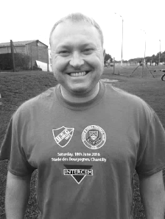
Also, thanks to everyone for their continued support.

Manders

Milestones
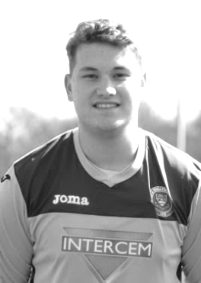
Last Saturday at North Greenford United Michael Eacott made his 100th appearance for our club. Michael made his debut along with five other players in our 2-0 win at Farnham Town on 2nd August 2014 after joining us from Colliers Wood United. Since then he has proved to be extremely reliable and a large part of our good form over that time.

Big Mike had an excellent game at Hanworth Villa that he considered his best performance for the club although there have been many others and hopefully there will be many more to come.

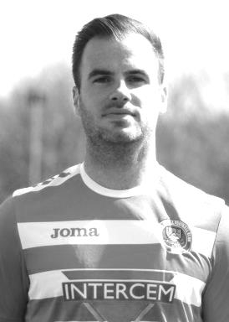
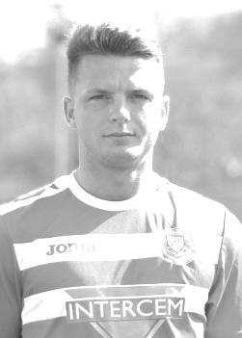
Also last Saturday Reisse Griffin made his 50th appearance for the Salts. Our hard working winger joined us at the start of last season from local football and was identified by Glyn Mandeville as the hardest trainer at the club last season. He was out for a while with a bad knee injury at the start of last season but has been regular ever since and has recently added a new string to his bow as emergency left back.

Finally, today Alex McKay should make his 150th appearance, having made his debut way back on 20th December 2008. A versatile player who started in defence but now spends more time protecting it, he is a danger to watch from set pieces and has scored twice on two occasions for the club, most notably with a last minute winner against Windsor.

Congratulations to all three of you!

Latest Results and Fixtures
F.A. Vase Second Qualifying Round – Saturday 24th September
Abbey Rangers | 1-0 | Badshot Lea
Bedfont & Feltham | 2-4 | Sun Sports
Frimley Green | 0-3 | Walton & Hersham
Horley Town | 1-0 | Selsey
North Greenford United | 1-2 | Oxhey Jets
Thrapston Town | 3-1 | CB Hounslow United
Westfield | 0-1 | Haywards Heath Town
Combined Counties League Cup 1st Round – Saturday 24th September
Worcester Park | 2-1 | Dorking
Combined Counties League – Saturday 24th September
Epsom & Ewell | 4-0 | Knaphill
Hanworth Villa | 1-0 | Colliers Wood United
Raynes Park Vale | 4-0 | Chertsey Town
Spelthorne Sports | 3-0 | Guildford City
Sutton Common Rovers | 0-1 | Camberley Town
Windsor | 5-0 | Farnham Town
F.A. Vase Second Qualifying Round – Sunday 25th September
Wellingborough Town | 0-2 | Bedfont Sports
Combined Counties League – Tuesday 27th September
Badshot Lea | 0-9 | Hartley Wintney
CB Hounslow United | 2-4 | Knaphill
Farnham Town | 3-1 | Sutton Common Rovers
Walton & Hersham | 1-1 | Abbey Rangers
Westfield | 2-1 | Epsom & Ewell
Combined Counties League Cup 2nd Round – Weds 28th September
Epsom Athletic | 1-5 | Windsor
Combined Counties League – Wednesday 28th September
Bedfont Sports | 1-2 | AFC Hayes
Colliers Wood United | 0-3 | Camberley Town
Guildford City | 5-1 | Raynes Park Vale
Combined Counties League – Saturday 1st October
Abbey Rangers | 1-0 | Sutton Common Rovers
Bedfont & Feltham | 0-1 | Badshot Lea
Camberley Town | 4-2 | Spelthorne Sports
Chertsey Town | 3-2 | AFC Hayes
Colliers Wood United | 3-3 | CB Hounslow United
Knaphill | 1-3 | Guildford City
North Greenford United | 0-2 | Farnham Town
Raynes Park Vale | 0-4 | Hartley Wintney
Latest Results and Fixtures
Combined Counties League – Saturday 1st October
Walton & Hersham | 1-1 | Epsom & Ewell
Westfield | 2-1 | Hanworth Villa
Windsor | 2-1 | Horley Town
Combined Counties League Cup 1st Round – Tuesday 4th October
Spelthorne Sports | 1-4 | Sutton Common Rovers
Combined Counties League Cup 2nd Round – Tuesday 4th October
AFC Hayes | 3-4 | Balham
Badshot Lea | 0-5 | Guildford City
Chertsey Town | 1-2 | Camberley Town
Cobham | 1-3 | Chessington & Hook United
Frimley Green | 1-2 | Banstead Athletic
Hartley Wintney | 4-0 | AC London
Horley Town | 2-2+ | Sheerwater
Horley Town won 5-4 on penalties
Raynes Park Vale | 2-0 | Colliers Wood United
Combined Counties League – Tuesday 4th October
North Greenford United | 1-1 | Bedfont & Feltham
Combined Counties League – Saturday 8th October
AFC Hayes | 1-1 | Sutton Common Rovers
Badshot Lea | 2-1 | North Greenford United
Bedfont Sports | 2-1 | Raynes Park Vale
CB Hounslow United | 0-3 | Camberley Town
Farnham Town | 1-2 | Epsom & Ewell
Guildford City | 3-3 | Windsor
Hanworth Villa | 2-1 | Knaphill
Hartley Wintney | 4-2 | Abbey Rangers
Horley Town | 1-0 | Chertsey Town
Spelthorne Sports | 2-0 | Bedfont & Feltham
Westfield | 1-2 | Colliers Wood United
Combined Counties League – Monday 10th October
Abbey Rangers | 1-1 | AFC Hayes
Sutton Common Rovers | 1-1 | Westfield
Combined Counties League Cup 2nd Round – Tuesday 11th October
Ash United | 2-0 | Farleigh Rovers
Hanworth Villa | 2-4+ | Epsom & Ewell
Combined Counties League – Tuesday 11th October
CB Hounslow United | 2-3 | Guildford City
Knaphill | 3-1 | Windsor
Latest Results and Fixtures
Combined Counties League – Tuesday 11th October
North Greenford United | 8-0 | Chertsey Town
Spelthorne Sports | 2-1 | Walton & Hersham
Combined Counties League – Wednesday 12th October
Colliers Wood United | 3-0 | Bedfont & Feltham
Combined Counties League Cup 2nd Round – Saturday 15th October
Staines Lammas | 0-1 | Farnham Town
Combined Counties League – Saturday 15th October
Abbey Rangers | 0-3 | CB Hounslow United
Bedfont & Feltham | 0-3 | Knaphill
Camberley Town | 0-1 | Hanworth Villa
Chertsey Town | 2-2 | Spelthorne Sports
Colliers Wood United | 1-1 | Guildford City
North Greenford United | 2-1 | Epsom & Ewell
Raynes Park Vale | 1-0 | AFC Hayes
Walton & Hersham | 3-1 | Horley Town
Westfield | 1-2 | Bedfont Sports
Windsor | 0-2 | Hartley Wintney
Combined Counties League – Monday 17th October
Sutton Common Rovers | 1-2 | Colliers Wood United
Combined Counties League – Tuesday 18th October
Bedfont & Feltham | 1-3 | AFC Hayes
Hartley Wintney | 5-0 | Bedfont Sports
Walton & Hersham | 1-1 | Chertsey Town
Combined Counties League – Wednesday 19th October
Guildford City | 1-1 | Westfield
F.A. Vase First Round – Saturday 22nd October
Abbey Rangers | V | Tunbridge Wells
Bedfont Sports | V | Buckingham Town
Eastbourne United | V | Horley Town
Epsom & Ewell | v | Bridon Ropes
Walton & Hersham | V | Thame United
Combined Counties League – Saturday 22nd October
CB Hounslow United | V | Raynes Park Vale
Guildford City | V | North Greenford United
Hanworth Villa | V | Bedfont & Feltham
Hartley Wintney | V | Colliers Wood United
Knaphill | V | Westfield
Spelthorne Sports | V | AFC Hayes

First Eleven Appearances 2016/17 - (max 17)
Name | Debut | 2016/17 |  |  |  | Career Totals
 |  | App | Sub | Total | Goals | App | Sub | Total | Goals
CLARK-GLEAVE Charlie | 23/08/2016 | 1 | 1 | 2 | 0 | 1 | 1 | 2 | 0
COOPER-SMITH Daryl | 03/01/2015 | 13 | 1 | 14 | 15 | 43 | 9 | 52 | 35
DEAN Dan | 02/08/2014 | 9 | 1 | 10 | 0 | 77 | 5 | 82 | 2
EACOTT Michael | 02/08/2014 | 14 | 0 | 14 | 0 | 99 | 1 | 100 | 0
FARRELL Matt | 02/08/2014 | 16 | 0 | 16 | 9 | 102 | 4 | 106 | 27
FERDINANDO Matt | 20/09/2014 | 5 | 3 | 8 | 1 | 58 | 9 | 67 | 15
GALLAGHER Jordan | 07/08/2016 | 5 | 9 | 14 | 3 | 5 | 9 | 14 | 3
GRIFFIN Reisse | 08/08/2015 | 15 | 1 | 16 | 2 | 43 | 7 | 50 | 4
HASTINGS Craig | 08/08/2015 | 9 | 5 | 14 | 0 | 46 | 9 | 55 | 0
HEAGNEY Adam | 16/08/2016 | 12 | 2 | 14 | 0 | 12 | 2 | 14 | 0
HENDRY Rob | 08/08/2015 | 12 | 4 | 16 | 2 | 42 | 15 | 57 | 14
MCKAY Alex | 20/12/2008 | 9 | 2 | 11 | 2 | 117 | 32 | 149 | 10
NEALE Tom | 13/10/2015 | 6 | 5 | 11 | 7 | 22 | 24 | 46 | 17
NORTH Rhys | 16/08/2015 | 2 | 2 | 4 | 0 | 19 | 9 | 28 | 1
NWACHUKWU Jason | 01/10/2016 | 2 | 2 | 4 | 0 | 2 | 2 | 4 | 0
PANAYIOTOU Savvas | 03/01/2015 | 11 | 3 | 14 | 0 | 43 | 11 | 54 | 7
PRICE Matt | 23/08/2016 | 2 | 0 | 2 | 1 | 2 | 0 | 2 | 1
ROBINSON Sam | 22/10/2011 | 7 | 1 | 8 | 1 | 61 | 6 | 67 | 14
SALEH Mennar | 24/09/2016 | 0 | 2 | 2 | 0 | 0 | 2 | 2 | 0
SMITH Matt | 08/08/2009 | 0 | 1 | 1 | 1 | 91 | 44 | 135 | 11
TANTON Matt | 02/08/2014 | 14 | 1 | 15 | 0 | 71 | 5 | 76 | 2
TAYLOR James | 26/08/2013 | 16 | 1 | 17 | 0 | 102 | 13 | 115 | 6
THOMPSON Elliott | 09/02/2016 | 3 | 0 | 3 | 1 | 7 | 9 | 16 | 1
TURPIE Alistair | 31/03/2016 | 3 | 0 | 3 | 0 | 5 | 0 | 5 | 0
WATRET Jack | 02/08/2016 | 1 | 0 | 1 | 0 | 1 | 0 | 1 | 0

From behind the goal
Epsom & Ewell 4 - 0 Knaphill
Combined Counties League - Premier Division - Saturday 24th September 2016

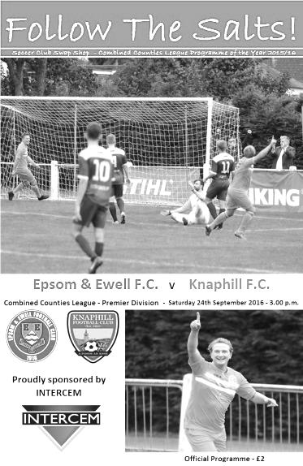
Depleted Salts outplay Knappers

Knaphill are a very good team. They finished last season in arguably better form than any other club and kept their squad together. I certainly had them down for a top three finish this season and their early form had given me no reason to change that view. Bearing this in mind, and the fact that we were missing leading scorer Daryl Cooper-Smith, the injured Rob Hendry and Matt Ferdinando and the absent Sam Robinson, this was quite clearly our best performance of the season as we took the game to our visitors from the start and by the end of the match had run away with it, restricting them to just one shot on target in the process.

It has been a strange season so far. We have had some devastating performances going forward and some matches where we just didn't get going and found ourselves on the wrong end of a heavy scoreline. This time we put together a great 90 minutes, and our clean sheet, the fourth in five matches, shows that our Management team appear to have the balance right now.

We made three changes from our win at Badshot Lea. In place of the injured Hendry came Jordan Gallagher, while Tom Neale started up front in place of Cooper-Smith. Finally, Captain Dan Dean had more or less recovered from illness and took his place alongside James Taylor with Craig Hastings moving onto the bench.

Neale tested out any lingering injury concerns early in the match when he acrobatically leapt into an overhead kick from Griffin's pass, but while his contact was on target, Richard Shelley in the Knaphill goal had no difficulty in collecting the ball and the visitors responded with a long range effort that was well wide of Michael Eacott's goal. However, the pattern of the early play was very positive. Appearing to have an extra man in midfield we kept possession well and pushed them back with Gallagher on the right and Griffin on the left both causing trouble, despite usually operating from the opposite flanks.

Agi Panayiotou was buzzing around too and he put in the first dangerous ball of the afternoon but just as it seemed as though his low ball in would be met by the waiting Neale, a last minute clearance from a defender denied him. That wasn't quite the end of the story though as his contact sent the ball towards the top corner of his own goal and Shelley made a brave intervention to prevent the own goal, colliding with the post as a result and requiring treatment, which would lead to some first half injury time. This would prove to be very important in the course of the game.

From the corner Alex McKay met Panayiotou's near post delivery and his on target volley cannoned off a defender for another set piece, although this came to nothing. The visitors responded in the 21st minute with a powerful strike that Eacott was well positioned to block and Matt Tanton was forced to head over his own bar but the resultant danger was cleared and we went back on the attack.

We then had a moment of controversy in the 28th minute when Neale was put through with a great pass and as he bore down on goal a defender came in from the side and took both man and ball, leaving Neale crumpled in a heap and requiring treatment. It was clear to me and indeed the Knaphill keeper too as we discussed it during the delay that he had got the man first but the referee decided otherwise, reprieving the inevitable red card that would have followed, even bearing in mind the new law amendments. If this

sounds like I am being critical, I must be pointed out in balance that I felt the referee got absolutely everything else right and he was constantly up with play throughout the match.

As the game went on and remained goalless, you wondered whether the decision would come back to hurt us. The game became a little more even for a while, the ball spending much of its time in the middle of the park, but two minutes into first half injury time a low, raking crossfield ball from Gallagher was placed into a really dangerous area and with Griffin, a defender and Shelley all trying to get there first it was our speedy winger who just got a toe to the ball 12 yards out. The contact was enough to divert the ball towards the net and we all knew it was going in but Griffin made sure from a couple of feet out.

It was the least we had deserved to that point as our work rate had been first class and the second half continued in a similar vein. With a slight breeze behind us, Neale, Panayiotou and then Griffin all had attempts from distance but the lead remained at one. Griffin was accidentally caught on the edge of the area but Matt Farrell's free kick was easily saved. Some say that the harder you work, the luckier you get and the second goal in the 64th minute contained a degree of fortune. Neale found Griffin who returned the ball into his path with a great chip and from twenty yards out Neale drove the ball powerfully at goal. Shelley made a fine save, at least, it appeared that way as the ball flew up at least twenty feet in the air, but then dropped into the net before their defender was able to reach it. It was an unfortunate moment for the visitors but you don't score if you don't shoot and with much of the play at their end, it was no real surprise that we had extended our lead.

The visitors pushed for a while but wasted a free kick badly and in the 78th minute we scored a third goal. We had put a fair bit of pressure on once again and the ball fell to Farrell about twenty yards out. His low shot was off target but flew through a crowd of players pushing up to Griffin who killed the ball dead with his first touch, enabling him to casually clip the ball past the exposed Shelley with the back line appealing for offside. It was impossible for us to see whether that was the case or not, but the Assistant was extremely well positioned and was of the view that a defender was slow coming out, so the goal stood.

This frustrated the opposition and a couple of yellow cards followed for dissent after they were then denied a free kick on the edge of the area after a contact with Tanton who was himself booked a minute later after a clumsy trip.

We made a couple of substitutions at that point with Dean able to take a well earned rest and Tanton being withdrawn. Griffin retreated to left back so we could get a look at new boy Mennar Saleh, who in under ten minutes on the field showed a lot of promise. He was responsible for initiating our fourth goal with a mazy run that drew the defenders, so that when he squared the ball to Gallagher, he had time and space to find Farrell on one of his Lampard-like runs and from twelve yards out he casually slotted the ball across Shelley into the far corner in the 93rd minute for his eighth goal of the season. How anyone could have the energy left to make that run after 90 minutes of competitive football is anyone's guess!

The visitors had the final attempt of the match with a shot that went well wide from 20 yards and although they never gave up, we were red hot yesterday and kept them and their much vaunted attackers out of the game completely. It is just as well we are getting into form as we face two more very tricky matches at Westfield and at Walton & Hersham in the next week. If we can win both of them, I am sure we will be involved in the title race right to the end once again. Our performance here would have beaten a lot of higher division teams, so let's hope it continues!

Epsom and Ewell: Michael Eacott, Adam Heagney, Matt Tanton, Dan Dean (c), James Taylor, Alex McKay, Reisse Griffin, Matt Farrell, Tom Neale, Savvas 'Agi' Panayiotou, Jordan Gallagher

Subs: Craig Hastings for Dean (81), Mennar Saleh for Tanton (85), Charlie Clark-Gleave for Neale (91)

From behind the goal
Westfield 2-1 Epsom & Ewell
Combined Counties League - Premier Division - Tuesday 27th September 2016

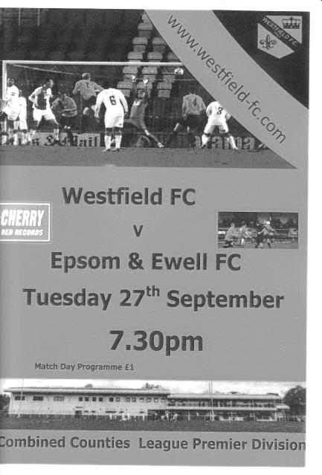
'Field retain perfect record at Salts expense

Our recent run of tough fixtures continued on Tuesday evening at Woking Park as we took on Westfield and their perfect League record. By the end of the match it was clear to see why they had it, as a particularly impressive first half left us with a mountain to climb in the second and the result could arguably have been worse, had it not been for a handful of fine saves from Michael Eacott at the death.

Following our comprehensive win over Knaphill on Saturday an unchanged eleven was no surprise and we went into the match in a confident mood against a team that had required a late winner to defeat the same opposition just seven days ago. Eacott was in action within the first 30 seconds getting in a good position to block a far post header, but we went behind in the 8th minute. A low shot was fired in and although Eacott made a good low save, the danger wasn't cleared and the ball was fired back into the net by Ryan O'Toole.

It was a disappointment to concede so early against a team that had only conceded three league goals in their eight matches so far, but our attempts to build any momentum and try to test their centre half Dale Burnham who had to go in goal following the sudden illness of their regular keeper that afternoon were difficult against a well organised team that retained possession well on a wide pitch. So much so in fact, that we didn't register a shot on target in the first half whatsoever.

However, at the other end it was quite busy. A Westfield striker knocked a good left wing cross over Eacott's bar at full stretch and a few minutes later Eacott had to be out quick, forcing an attacker to shoot into the side netting. We had a little spell just after the half hour mark when we forced three corners in a row, but the deliveries caused no difficulty for the home team and we were soon requiring Dan Dean to make a saving challenge at the other end as Westfield came back at us again.

Jordan Gallagher was tripped on the edge of the Westfield area but the delivery from Agi Panayiotou, making his 50th appearance, was cleared and shortly after this a deep left wing cross caught Eacott out and was headed in by Aaron Watson; the ball going in

off both head and shoulder as it dribbled into the net in the 42nd minute.

Within a minute of the second half commencing Tom Neale had struck a shot on target from the edge of the box that was gathered by temporary keeper Burnham at the second attempt and in the 49th minute we managed to pull a goal back when Alex McKay sent in a cross from the right and the ball made its way to Neale who took a touch before scoring from close range. Now maybe the momentum of the game would change.

And the second half would prove to be a more even contest. Although Westfield had played well in the first half, we knew we could play better and for a while we asked a few questions. Dean met a Panayiotou corner with a towering header, although it was wide, but before it went out McKay was able to reach it although he was at full stretch and couldn't get a powerful effort on target. Unfortunately in landing after this header our Captain aggravated an injury that he had picked up on Saturday and he would be replaced by Craig Hastings soon after this with Matt Farrell taking the arm band.

The home side raised their game though and a corner was met by a glancing header across the face of our goal before we needed a hefty clearance just in the nick of time to avert what would have been a third goal. Mennar Saleh replaced Neale, who was also by now struggling with an injury he brought into the game but we were getting pushed back again and wouldn't threaten for the remainder of the match.

Eacott controlled an over hit backpass really well in the 83rd minute before making three fine saves in the final minutes of the match, all of which would have resulted in goals had he not intervened and the match ended in a 2-1 defeat that could possibly have ended up worse had it not been for our keeper's heroics at the end of the match. However, we could have no complaints about the scoreline.

In summary, just three days after producing our best display of the season, we came up against the best team we have played all season and if Westfield can retain their players, Hartley Wintney may not have it all their own way in the title race this season. For us, I could list the growing number of injuries and suspensions that were added to last night when Dean re-injured himself and Neale probably wouldn't have played had there been any other striking options available.

Additionally, Matt Tanton picked up his fifth booking of the season and will miss a game shortly as a result. The same crowd of walking wounded face another tough match at Walton & Hersham this Saturday, and so it was good to see Rob Hendry back on the field, if only for a minute or two at the end of the match while Matt Ferdinando is getting closer to an appearance also. Hopefully they will both be available for the trip.

Epsom and Ewell: Michael Eacott, Adam Heagney, Matt Tanton, James Taylor, Dan Dean (c), Alex McKay, Jordan Gallagher, Matt Farrell, Tom Neale, Savvas 'Agi' Panayiotou, Reisse Griffin

Subs: Craig Hastings for Dean (70), Mennar Saleh for Neale (76), Rob Hendry for Gallagher (90)

Club Records - 22nd October
Date | Day | Competition |  | Opponents |  | Scorers
22/10/27 | Sat | Amateur Cup 2q | A | Reigate Priory | 7-1 | F.Behn (3), R.Marlow (2), J.Parr, R.Sperring
22/10/32 | Sat | Amateur Cup 2q | H | Sutton United | 4-1 | R.Marlow (2), B.Marlow, A.Rance
22/10/38 | Sat | London League | H | Wandsworth United | 5-0 | M.Snowball (2), J.Kinsela, A.Curtis, o.g.
22/10/49 | Sat | Corinthian League | A | Grays Athletic | 1-7 | D.Ralph
22/10/55 | Sat | F.A. Cup 3q | H | Margate | 1-3 | R.Colfar
22/10/60 | Sat | Surrey Senior Cup 2q | A | Petter Sports | 0-3
22/10/66 | Sat | Athenian League 2 | A | Ruislip Manor | 1-5 | T.Thomas
22/10/77 | Sat | Isthmian League 2 | A | Hemel Hempstead F.C. | 3-1 | S.Delaney, I.Ferrar, T.Tuite
22/10/83 | Sat | F.A. Trophy 1q | A | Folkestone | 0-0
22/10/85 | Tue | Isthmian League  Premier Division | A | Hitchin Town | 1-2 | P.Kemp
22/10/94 | Sat | Isthmian League 3 | H | Harlow Town | 2-2 | D.Fry (2 pens)
22/10/05 | Sat | Isthmian League 2 | A | Kingsbury Town | 0-1
22/10/11 | Sat | Combined Counties  Premier Division | A | Wembley | 1-4 | M.Jarman
22/10/13 | Tue | Surrey Senior Cup 1 | H | Chertsey Town | 1-0 | J.Cottee
Historical Decades
90 years ago – Epsom Town F.C.
23/10/26 | Sat | Amateur Cup 2q | A | Leyland Motors | 5-2 | R.Marlow (3), J.Parr, R.Sperring
80 years ago – Epsom F.C.
24/10/36 | Sat | Amateur Cup 2q | H | P.O.Engineers | 5-2 | J.Morgan (2), H.Pullen, T.Dunne, B.Randall
70 years ago – Epsom F.C.
19/10/46 | Sat | Friendly | A | Barclays Bank | 5-3 | G.Brogdale (3), K.Holliday (2)
60 years ago – Epsom F.C.
20/10/56 | Sat | Corinthian League | A | Maidenhead United | 3-5 | R.Colfar, J.Bangs, D.Hermitage
50 years ago – Epsom & Ewell F.C.
15/10/66 | Sat | Athenian League 2 | H | Ware | 4-5 | T.Williams (4)
40 years ago – Epsom & Ewell F.C.
23/10/76 | Sat | F.A. Cup 3q | H | Enfield | 1-1 | G.O'Rourke (pen)
30 years ago – Epsom & Ewell F.C.
25/10/86 | Sat | Isthmian League 1 | A | Stevenage Borough | 0-1
20 years ago – Epsom & Ewell F.C.
19/10/96 | Sat | Isthmian League 3 | H | Braintree Town | 2-5 | A.Boxall (2, 1 pen)
10 years ago – Epsom & Ewell F.C.
21/10/06 | Sat | Combined Counties  Premier Division | A | North Greenford United | 1-2 | A.Pero

History Corner – 22nd October
90 years ago this week we visited the Hawker Sports Centre in Richmond Road, later home of Hawkers Sports in the Surrey Senior League, for an Amateur Cup tie with Leyland Motors. The Motormen had already defeated Mitcham Wanderers in the previous round and Wimbledon in the F.A. Cup. Although they weren’t in the Surrey Senior League this season, they caused the only two League defeats we had suffered on our way to the title in 1925/26. However, Reg Marlow had other ideas this time and he scored a hat trick, including the one pictured below, as we crushed them 5-2 on their own patch. Wimbledon would knock us out in the final qualifying round.

89 years ago today we had another Amateur Cup tie, this time against Reigate Priory. Although drawn away, the match was switched to West Street and we won the match 7-1 with Marlow getting another two but being upstaged by Freddie Behn, a right winger born in what we now know as Zimbabwe, who joined the club from Ewell F.C. and he scored a hat trick this day, although our run was ended by Met Police in the next round.

70 years ago this week Gordon Brogdale scored a hat trick in our 5-3 friendly win over Barclays Bank. The works teams were decent back then and this was a tough work out. Brogdale had joined us as a promising 15 year old, playing for the Reserves in August of 1934, but his first team debut didn’t come until 1937 and he then went on to play for Crystal Palace, although it is not clear exactly what level he reached there. He returned after the war and scored 44 goals in 32 appearances that season and would get 27 in 23 matches this season, but despite only being 28 or 29 by then his powers were on the wane and he made only a handful of appearances over the next few years before either leaving or retiring in 1951/52.

61 years ago today Our keeper Geoff Porter was blamed as we let a half time lead slip as we were knocked out of the F.A. Cup by Margate. However, what many people didn’t know was that our keeper had chipped a bone in his thumb in the first half and couldn’t hold the ball in the second. After a bit of time off to recover from the injury Geoff decided to end his career with us and become a police officer. Geoff is 83 now and came up to a couple of our matches last season. He is still a supporter of the club despite the way he was treated back then.

50 years ago this week we led Ware 3-0 in an Athenian League match but were eventually defeated 5-4 at West Street! Player / Manager Tony Williams scored all four goals for us and this remains the last time that anyone scored a hat trick, yet we still lost! Williams is best known for creating the Non-League Year Books that we still see on an annual basis, although his son does much of the work now while he enjoys his retirement in a sleepy little Somerset village.

50 years ago this week we hosted Isthmian League Champions Enfield at West Street and gave them a massive scare, leading through former Wimbledon striker Gerry O’Rourke until they equalised with seven minutes remaining. They edged us out in the replay at Southbury Road by a goal to nil and went on to reach the second round before being defeated by Crystal Palace.

From behind the goal
Walton & Hersham 1-1 Epsom & Ewell
Combined Counties League - Premier Division - Saturday 1st October 2016

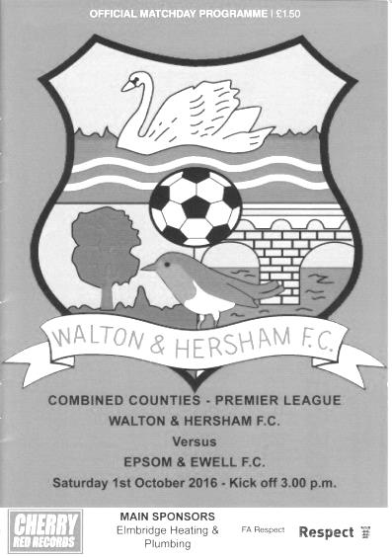
Patched up Salts secure a point at the Lane

The 100th match in charge for our Management team of Glyn Mandeville and Matt Smith coincided with the 50th meeting between our club and Walton & Hersham; a club we have faced in the Surrey Senior League, the London League, the Corinthian League, the Isthmian League and now the Combined Counties League following their relegation last season. The match itself will not live long in the memory but a draw was the right result.

Just before the match Captain Dan Dean failed a fitness test after his injury at home to Knaphill which was then aggravated at Westfield and Craig Hastings came in alongside James Taylor. Deano sat on the bench along with Tom Neale who had also limped off in discomfort on Tuesday while Matt Ferdinando was also available after a few matches watching from the bench but would finally get back on the pitch this week. Also there was our latest new player Jason Nwachukwu who had joined us from Corinthian Casuals. Fortunately Rob Hendry was able to start in Neale's place, following his recovery from an ankle injury sustained at Badshot Lea while Daryl Cooper-Smith completed the final match of his suspension.

It was our first visit to Stompond Lane since a horrendous afternoon in November 2003 when we conceded eight times following an early sending off. In fact we had not even scored there in the League since December 1983 with our last League win coming way back in April of that year, so when considering this in addition to our absences and the Swans current position of third, expectations may not have been incredibly high as we made possibly our last ever visit to the historic ground. It looked in a sorry state with the far side terracing closed down and almost everyone confined to the main stand or its vicinity, but is still worth a visit if you have never been there.

We had an early concern when Taylor was injured with just three minutes on the clock, but fortunately he was able to run it off after a while and the opening few minutes provided little to write about as the ball was mainly in the air and along the stand side touchline. Adam Heagney appeared to have as many touches as the rest of our players combined during that opening spell but despite the workload, nothing dangerous was created against him.

Unfortunately we weren't able to create much either with many deliveries throughout the match not getting past the first defender. Only when Ferdinando came on towards the end

for a typical Ferdi cameo (two good runs and a dissent booking!) did we see some quality deliveries into the area and this is an area that other members of our team have to improve on in games like this where chances are few.

As we approached the half hour mark the home side started to have a good spell sparked by a thirty yard drive from former Salt loanee Howard Newton which Michael Eacott tipped over. A dangerous left wing cross was palmed away at full stretch by Eacott, although fortunately the ball had just gone out of play before it had been delivered. Then Taylor had to head a hooked shot off the line before a header from Jamil Okai was wide from close range. It looked they were about to take a grip on the match at that point.

But as is so often the case after a spell of good pressure for one team, we went down the other end and took the lead and it was good to finally see a deep set piece delivery, given for a clumsy foul on Hendry. The free kick was met at the far post by Hastings, who realised that he was never going to get it on target from his position so cleverly headed the ball behind him where Alex McKay was waiting and his early shot from an angle caught our Liam Beach in the Walton goal from 12 yards in the 37th minute. In a game of few opportunities on a bobbly pitch and some extremely erratic officiating from all three men in black there was little in the way of flow to the game, so maybe the one goal would prove to be enough.

In the second half Jordan Gallagher and Reisse Grifffin swapped flanks and Matt Tanton nearly surprised Beach with a thirty yard effort that just missed the post. Unfortunately just as we were looking to extend our lead the home side scored an equaliser in the 52nd minute. A ball placed over the top but between our centre halves was perfect for Newton who held off the challenge before burying the ball low just inside Eacott's left hand post.

The next period of the match was very important. Would the Swans be able to ride the momentum from their goal or would be respond by raising our game? It's fair to say that we fought back well. We had the first opportunity when Matt Farrell put Hendry through but the home team just cleared the danger as our man was about to pull the trigger. However, Hendry was causing a few problems for the opposition and forced a defender into a yellow card after he was brought down just before he got into the area. Moments later an Agi Panayiotou shot from 25 yards flew up off a headed half-clearance and fell to Hendry twelve yards out but it was a difficult one to deal with and as the ball dropped he was only able to head the ball tamely over.

Hendry then had an effort from 35 yards before being set off down the wing by a Peter Schmeichel-like throw from Eacott that cleared the half way line before being brought down and earning another Walton defender a yellow card. However, we were unable to score a second goal and we nearly conceded one of our own after Tanton gave Hastings a back pass that hopped over his foot and he had to do really well to recover with a saving tackle, just as it looked as though their striker would be through on goal.

Ultimately a point was a completely fair result as both teams looked good in patches but neither could say they did enough to deserve all three points.

Epsom and Ewell: Michael Eacott, Adam Heagney, Matt Tanton, James Taylor, Craig Hastings, Alex McKay, Reisse Griffin, Matt Farrell (c), Rob Hendry, Savvas 'Agi' Panayiotou, Jordan Gallagher
Subs: Matt Ferdinando for Griffin (68), Tom Neale for Hendry (74), Jason Nwachukwu for Gallagher (82)

From behind the goal
Farnham Town 1-2 Epsom & Ewell
Combined Counties League - Premier Division - Saturday 8th October 2016

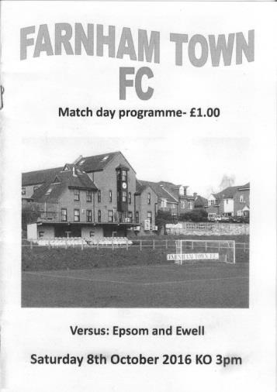
Salts off to a flyer as three points claimed at the Memorial Ground

Our third straight win at Farnham Town's Memorial Ground was achieved with a minimum of fuss as we got off to a flying start, scored a second goal just before the break and probably should have added to our lead before a late goal for the home team left us looking at our watches a little more than we probably should have needed to.

We made two changes from our draw at Walton & Hersham with Captain Dan Dean being fit enough to reclaim his position at the heart of the defence at the expense of Craig Hastings, while up front Tom Neale was fit enough to start which moved Rob Hendry out to the left with Jordan Gallagher on the bench. Also on the bench was Daryl Cooper-Smith after completing his three match suspension.

If seeing our leading scorer on the bench was maybe a surprise, we proved that we have other goal scorers in the team and were ahead in just 63 seconds when a defensive pass across the edge of the Farnham penalty area was intercepted by Hendry who took the ball around the nearest defender and drilled the ball past Richard Ossai in the Farnham goal to open our account. Neale nearly made it two - nil moments later after he outpaced his man but his low shot was kept out by the keeper's feet and from the next ball in Reisse Griffin put a header on target but not with enough power to cause concern.

There was a moment of worry at the other end when Michael Eacott was forced into a hurried clearance during which one of the Farnham players were injured but claims of a penalty were rightly waved away by the referee. The game then went quiet for a while with our boys holding the balance of possession but looking a little predictable in places as we found players on each flank but the deliveries were not good enough to do anything else than provide catching practice for Ossai.

Eacott did have one save to make in the first half when after 29 minutes Farnham put together a good flowing move and when a low shot came in the ball was well blocked for a corner. We were soon back on the attack and Hendry met a Neale cross with a good far post header but was flagged offside in the process. Fortunately we wouldn't have long to wait before our lead was extended when Matt Farrell threaded a clever pass to Neale and he delayed his shot long enough to commit the keeper, enabling him to clip the ball into the corner in the 45th minute.

In the second half we caused some early danger when Alex McKay's header on the edge of the box found Griffin in space but he snatched at the shot and blazed it well wide from 12 yards. Adam Heagney had to be alert at the other end to make a last minute interception as the home team launched a rare attack but almost straight after that a good Agi Panayiotou

delivery was flicked on to McKay, but his header was well saved at close range with Neale's follow up also blocked by a defender before an offside flag against Farrell ended the attack.

In fact there were many erratic offside decisions throughout the match with the flag being raised almost immediately on some occasions, while on others we waited an age before a flag was lifted. Surely the referee needs to give some guidance or instructions to his Assistants on this point before the game starts as the players were left confused and the age old complaint of consistency arises as a result. James Taylor was flagged once despite the ball being well short of him, yet based on other occurrences he should have at least made contact before being called for offside. It was frustrating as the game broke up as a result and also led to trouble for Cooper-Smith who had only been on the field for six minutes before his frustrations with the decisions earned him a yellow card.

The next contentious incident occurred soon after this but with more serious repercussions. A Farnham free kick was delivered and the flag came straight up for offside, despite the ball going beyond the strikers to Eacott. However, our man was only able to palm the ball away at full stretch and we were under pressure. Eventually we got the ball but were still boxed in the corner and yet the referee still hadn't spotted the flag. As we cleared the ball out of play the referee was made aware of the flag, by which time it had been taken down! The referee spoke to the Assistant yet between them they still awarded the throw in. From the throw in the danger still wasn't cleared and led to a corner which was then bundled into our net from close range in the 73rd minute. Had the referee seen the flag originally, all of this wouldn't have occurred. Likewise had the Assistant kept his flag raised for longer we would also have remained two goals clear. Very frustrating!

We nearly responded immediately but Farrell maybe didn't realise what a good position he was in and struck his effort straight at the grateful Ossai from a couple of yards. Matt Ferdinando came on shortly afterwards and nearly scored twice in one move when a free kick was awarded for handball as close to the penalty area as I have ever seen. His effort around the wall was parried out to our right wing by the keeper but the ball was crossed straight back in where Ferdinando rose highest but was unable to get his header on target. As we went into injury time our third substitute Jason Nwachukwu was nearly able to score a third after a clever lob from Farrell put him through, but his low near post effort was kept out by Ossai's outstretched left hand. Cooper-Smith was waiting in the middle for a chance to mark his 50th appearance with more than his booking but it was not to be and a one goal win was the end result.

I recall our previous Manager Lyndon Buckwell once saying that sometimes you have to go to places and just get the job done. This was one of those days. We could have scored more on another occasion and we could have played better, but ultimately we did more than enough on a challenging playing surface to claim the three points and who knows where it could take us. Our last win at Farnham set us on a club record eight match away winning run. Let's hope for more of the same in our next two away matches.

Epsom and Ewell: Michael Eacott, Adam Heagney, Matt Tanton, James Taylor,
Dan Dean (c), Alex McKay, Reisse Griffin, Savvas 'Agi' Panayiotou, Tom Neale,
Matt Farrell, Rob Hendry

Subs: Daryl Cooper-Smith for Neale (72), Matt Ferdinando for Griffin (80),
Jason Nwachukwu for Panayiotou (85)

Centre page for results

Centre page for results

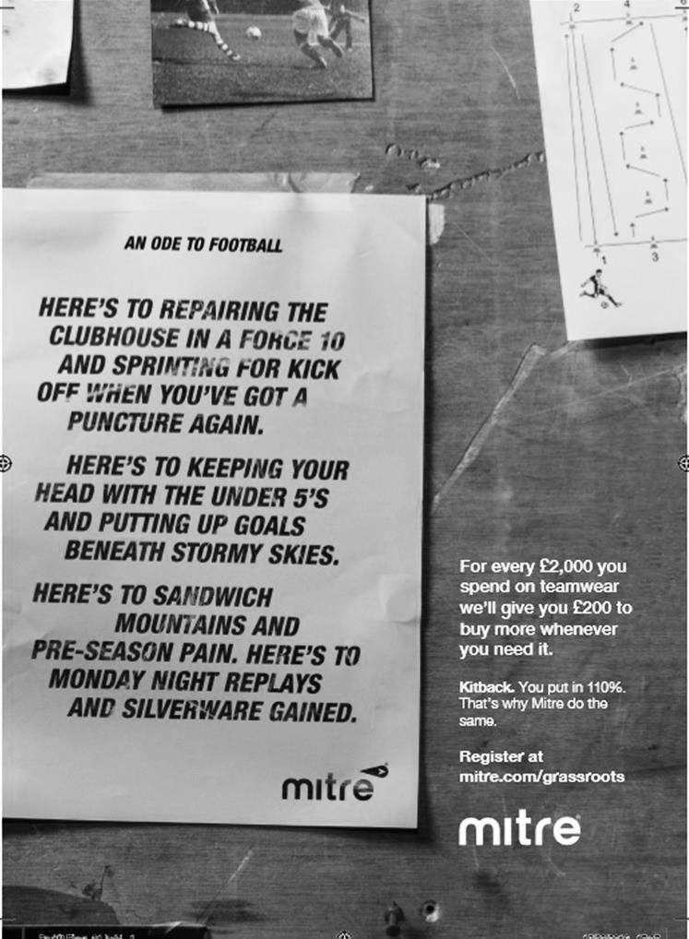

From behind the goal
Hanworth Villa 2-4 Epsom & Ewell – after extra time
Combined Counties League Cup – Second Round - Tuesday 11th October 2016

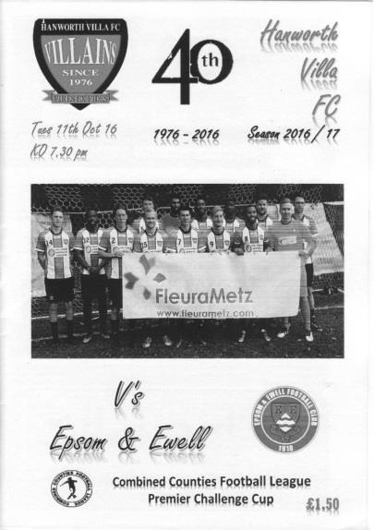
Eacott heroics enable Salts to progress at the Ranch

It might seem a little strange to those who weren't there for praising our young keeper, following our 4-2 win at Rectory Meadows, better known these days as the Ranch, in the League Cup. However, the true story is that we led 1-0 for a substantial period of time, largely due to some fine keeping from Michael Eacott, and although Hanworth Villa did eventually score an equaliser to force extra time, the truth is that we may not have reached that extra period if not for him.

In terms of personnel, Jason Nwachukwu was given his first start in place of Agi Panayiotou, while Daryl Cooper-Smith returned to the starting line up ahead of Tom Neale and Craig Hastings came in for Jason Taylor as we operated a bit of a rotation policy after our win at Farnham on Saturday. Additionally, Matt Tanton had to serve a one match suspension so Reisse Griffin moved to left back and Matt Ferdinando came in on the right wing as he continued to work his way back from injury.

Going into the contest, the two teams were closely matched in terms of their League position and most people expected a tight encounter where the tie might be decided by either an error or a moment of brilliance and that's how it looked like turning out as Daryl Cooper-Smith's incredible strike with the outside of his right foot from way out on the right in the 11th minute had proved to be the difference between the teams for so long.

There were other chances though and we could have been ahead in the fifth minute when Nwachukwu operated a perfect one-two with Cooper-Smith and was clean through but Bobby Khairi, late of AFC Hayes, made a fine stop and then saw the ball rebound out of play of our man for the goal kick! Cooper-Smith then put us ahead after receiving a ball down the line from Adam Heagney and as he took the ball inside his marker he let fly with a stunning strike, unleashing a dropping volley over Khairi and into the net. We scored a number of great goals last season but this one sits at the top of the list for 2016/17 so far.

The home team had started quite slowly but their wingers were getting them more into the game and there were two opportunities where a better contact by the striker would have left Eacott with no chance. Fortunately both were met by glancing headers and flew to safety beyond the far post. In between that we put together a good move that concluded with a low drive from Cooper-Smith in the 20th minute. The ball bobbled in front of Khairi who got a fainter touch on the ball than he would have liked, but it proved to be enough as the ball hit the post and bounced across the vacant goal before being cleared.

We had a scare in the 31st minute when Hastings was deceived by a long ball over the top and as it fell perfectly for the striker our man brought him down just outside the penalty area, earning a yellow card. Fortunately the wall did its job from the free kick, although we didn't clear the ball particularly well afterwards and Eacott made the first of his collection of top drawer saves by tipping the shot wide from

20 yards.

Nwachukwu made a good run towards goal but his shot was saved by Khairi while Griffin had a bit of space on the edge of the box and had a try that was not far wide. As the first half moved into injury time Ferdinando intercepted a poor clearance but with better options around him he went for goal from 30 yards and the effort was easily saved.

It was clear that this was going to be nip and tuck all the way. Our hosts came out slightly the stronger in the second half but they were unable to hit the target before they were unfortunate to see another attempt deflected for a corner in the 52nd minute. The game evened out for a while after that and Jordan Gallagher came on for the tiring Ferdinando after 65 minutes which may well have proved to be the game changer, although we didn't realise it at the time. Eacott made a good low save for a corner before Gallagher turned provider for Nwachukwu but his shot was over the bar from 20 yards while Farrell was wide from a similar distance shortly after this.

Eacott was getting busier now as Hanworth pressed for an equaliser and made another good save after 73 minutes. Panayiotou came on for Nwachukwu and nearly had an instant effect when he took advantage of a defensive mistake but his cross was just cut out by a defender at full stretch with Cooper-Smith and Gallagher waiting unmarked in the centre. A few minutes later Panayiotou was in a similar position and this time his cross was deep enough but Gallagher tried to take a touch and miscontrolled the ball out for a goal kick instead. Maybe next time if the opportunity arose he should just hit it first time he might have been thinking.

And we were all wondering if our chance to progress had disappeared when Hanworth Villa scored an equaliser in the 89th minute with their striker giving Eacott no chance from close range, and only a superb double save moments later kept us in the match as we nearly didn't reach the extra period. We have a good record here but have also conceded a number of late goals so it was a relief just to survive those final seconds.

But how would we react? Surely the home side would have the momentum? Well they did have the first real opportunity when a right wing cross fizzed across the face of our goal just ahead of their incoming player, but as the game went on we became stronger. Rob Hendry started to make progress on the left, earning a foul and a yellow card from the Hanworth 4. The kick came to nothing but Hendry was then fouled again shortly afterwards. James Taylor came on for the tiring Hastings and went straight upfield for the delivery but the defenders weren't watching Alex McKay who was able to reach a Gallagher inswinger to glance the ball into the net for his tenth goal for the club in the 100th minute. Two minutes later Gallagher got clean through as the home team pushed up but probably had too long to think about it and Khairi made a good save.

We scored our third goal after 110 minutes after Cooper-Smith had been fouled in the area by the Hanworth 4 who was fortunate to stay on the pitch as a result, having already been booked. Farrell tucked away the penalty to open a two goal deficit but within a minute the Villains pulled a goal back with a near post finish by Levi King and it was game on again. Not for long though as in the 114th minute Panayiotou made another fine run on the left and this time his deep cross was hit first time by Gallagher, his crisp low volley finding the net off the far post to clinch the match.

It had been a very even match but as it turned out the main difference between the sides was that of fitness as we were deserved winners by the end of the 120 minutes. Those at the game also had two added bonuses. Firstly, the League Cup Third Round draw was made by our League Secretary Alan Constable at half time, so we all knew that the winners would travel to either Worcester Park or Cove in the last 16, and we all had the benefit of missing the England match. Definitely time well spent at the Ranch!

Epsom and Ewell: Michael Eacott, Adam Heagney, Reisse Griffin, Craig Hastings, Dan Dean (c),
Alex McKay, Rob Hendry, Matt Farrell, Jason Nwachukwu, Daryl Cooper-Smith, Matt Ferdinando

Subs: Jordan Gallagher for Ferdinando (65), Savvas 'Agi' Panayiotou for Nwachukwu (74),
James Taylor for Hastings (98)

From behind the goal
North Greenford United 2-1 Epsom & Ewell
Combined Counties League - Premier Division - Saturday 15th October 2016

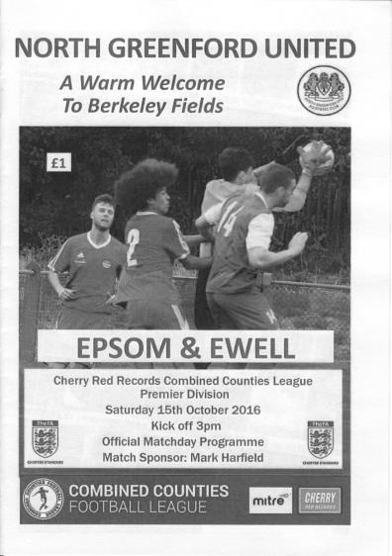
Bitter ending at Berkeley Fields

A competitive and entertaining match turned sour for the Salts in injury time when a complete absence of defensive marking enabled a right wing cross to be headed home from close range by the completely unmarked Charlie Conner. In that one moment all our hard work in getting back into the match counted for nothing.

It has to be said that we were second best over the ninety minutes and were arguably fortunate to be just the one goal down at half time, but we worked really hard to get back on terms in the second half and appeared to be finishing the stronger of the two teams but were unable to see it through for the second time this season, following an injury time winner for Windsor at Stag Meadow earlier in the season.

We went into the game in good form with wins at Farnham and Hanworth Villa, although the home side also had something to smile about for the first time this season after their 8-0 win over Chertsey Town and against a depleted Salts team missing Matt Tanton once again but also the heartbeat of the side in Matt Farrell, they took the game to us with what appeared to be a shoot on sight policy. Following an early Matt Ferdinando free kick from distance I noted five shots on our goal in the opening twenty minutes. The final one of these from George Moore produced a world class save from Michael Eacott, making his 100th appearance for the club, with his left hand to keep the powerful shot out.

We weren't producing a lot at the other end and things then got worse as Reisse Griffin, making his 50th appearance for the club, had to leave the field with a cut on his head, requiring the use of a spare shirt. Ironically while he was off the field we nearly took the lead as a right wing free kick from Matt Ferdinando was volleyed into the net brilliantly by Daryl Cooper-Smith from 12 yards only to see the Assistant's flag raised against him. It was impossible to see whether this was the case at the time but an extremely suspicious offside decision against Rob Hendry a couple of minutes later gave us doubts about the earlier decision.

Unfortunately we had gone behind by that point with Griffin still off the field. Almost immediately after our disallowed goal, the home side broke through and their striker reached the ball ahead of Eacott, lobbing him and then chasing the loose ball. He retrieved it just before it went out of play, although he was by then a little wide and we appeared to have got away with it as we half cleared the ball to the edge of the area. Not this time though as Moore drilled in a low strike that may have taken a slight deflection on its way

into the net in the 23rd minute.

We nearly conceded again when a deep right wing cross was met at the far post by a header that somehow went back across the face of goal. At the other end we were beginning to get a little more possession but were not creating nearly enough and the half ended with a couple of bookings, one for James Taylor and another for the home side's Carl Bower for a cynical foul on Hendry. The dangerous free kick from Agi Panayiotou was headed away by Jamal Velinor but we were unable to make the corner count for anything.

Still, going down the hill at North Greenford is usually the best direction to go and we were no doubt ready to go out and retrieve the position, but the first notable moment was a terrible decision by the referee not to play the advantage rule, blowing the whistle almost immediately as we were on an attack. The rule was brought in to help the officials and allow them to keep the game flowing so it is frustrating when they don't apply it.

Cooper-Smith tried his luck from 25 yards with the keeper off his line but the ball didn't quite come down in time before the home team missed a good chance to extend their lead with a far post header of a great right wing cross but the striker was unable to get the ball on target. After 57 minutes they did hit the target with a fine strike from 25 yards but Eacott was there to fingertip the ball over the bar. By this time though the home team should have been down to ten men after Bower wrestled Hendry to the ground after he had beaten him once again. Why the referee did not award a second yellow card is hard to understand, especially with the number of harsh red cards we have received in the last couple of seasons.

As the half progressed, Jason Nwachukwu started to get a little more involved and showed some potential with a good run which was halted by a clumsy foul right on the edge of the area and on another day might have ended with the award of a penalty. As it turned out it wouldn't matter as we scored our equaliser in the 64th minute directly from the free kick when Ferdinando's deep delivery was headed back across goal by Alex McKay. It may have been going in on its own but Cooper-Smith wasn't going to take a chance and headed the ball in from all of a yard out for his easiest goal of the season and his 15th in 14 matches; an impressive statistic.

He had another try shortly after this but was wide from the edge of the area with his left foot before each team had a loud penalty shout. Firstly when Griffin tussled for the ball in our area and five minutes later when Nwachukwu appeared to be forearmed to the ground by a defender. Ultimately neither were given and it looked as though the two teams would finish even until our horror ending.

If we had got a point it would have been a good one on the balance of play. Good teams manage to do this when they are not playing that well and I do consider us to be a good team this year. However, midtable sides show signs of inconsistency; brilliant at times but not so good at others, and right now this looks to be our fate. At least we can take some time out from the League now as it is the big Vase match next week. Maybe it will be our turn for a late winner then!

Epsom and Ewell: Michael Eacott, Adam Heagney, Reisse Griffin, James Taylor,
Dan Dean (c), Alex McKay, Matt Ferdinando, Savvas 'Agi' Panayiotou,
Daryl Cooper-Smith, Jason Nwachukwu, Rob Hendry

Subs: Craig Hastings for McKay (73) Jordan Gallagher for Hendry (75)

Bridon Ropes F.C. – History
Bridon Ropes F.C. began life as a factory team back in 1935. It was formed from workers at the British Ropes Works in Charlton, London, and became known as British Ropes F.C.

In the early days the club played in various minor local leagues until eventually joining the South London Amateur League, a few years later they started playing in the Greater London League which they left in 1975 to join the London Spartan League, still under the name of British Ropes, but in 1990 the factory changed its name to Bridon Ropes and the football club changed its name to Bridon Sports. They then won Division Two of the Spartan League in 1991–92 and the London Junior Cup. In 1992–93 the club changed its name to Bridon Ropes FC.

In 1997–98 they became founder members of the Spartan South Midlands Football League Division One South but then left the league the following season to become founder members of the London Intermediate League.

Bridon Ropes later joined the Kent County League Division One and were champions in the 2009–10 season, achieving promotion to the Premier Division.

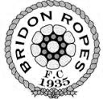
In 2011–12 they became founder members of the Kent Invicta Football League.

Southern Counties East League Division One Table
Up to date | P | W | D | L | F | A | Pts | GD
Rusthall | 13 | 9 | 4 | 0 | 32 | 10 | 31 | +22
Glebe | 11 | 8 | 2 | 1 | 29 | 7 | 26 | +22
Bridon Ropes | 12 | 7 | 2 | 3 | 20 | 14 | 23 | +6
Snodland Town | 13 | 7 | 2 | 4 | 24 | 24 | 23 | 0
Forest Hill Park | 14 | 7 | 2 | 5 | 21 | 28 | 23 | -7
Sutton Athletic | 12 | 7 | 1 | 4 | 38 | 19 | 22 | +19
Orpington | 13 | 6 | 4 | 3 | 24 | 17 | 22 | +7
Kent Football United | 10 | 7 | 0 | 3 | 31 | 9 | 21 | +22
Holmesdale | 12 | 5 | 4 | 3 | 20 | 15 | 19 | +5
Lydd Town | 12 | 5 | 3 | 4 | 21 | 23 | 18 | -2
K Sports | 11 | 4 | 5 | 2 | 26 | 20 | 17 | +6
FC Elmstead | 11 | 4 | 4 | 3 | 20 | 21 | 16 | -1
Phoenix Sports Reserves | 14 | 5 | 1 | 8 | 29 | 44 | 16 | -15
Meridian VP | 14 | 4 | 0 | 10 | 21 | 29 | 12 | -8
Eltham Palace | 13 | 3 | 3 | 7 | 19 | 29 | 12 | -10
Gravesham Borough | 10 | 2 | 3 | 5 | 17 | 24 | 9 | -7
Crockenhill | 13 | 2 | 2 | 9 | 11 | 31 | 8 | -20
Sporting Club Thamesmead | 9 | 1 | 2 | 6 | 15 | 22 | 5 | -7
Lewisham Borough | 13 | 0 | 0 | 13 | 8 | 40 | 0 | -32
Every Opponent A-Z
Over the years we have played many, many different opponents. Exactly how many is a difficult question, as it all depends on your definition. Are Camberley & Yorktown different to Camberley Town, or are Epsom Town different to Epsom F.C. or Epsom & Ewell F.C.?

In my analysis I have classed both of the above examples as the same team, and will work through them all from A to Z. Some we have played many times, whilst others we have met just once or twice. Enjoy!

Surbiton Town: Played 6 - W4 D1 L0 Abandoned 1 - F26 A11 - PPG - 2.60 - Fantastic
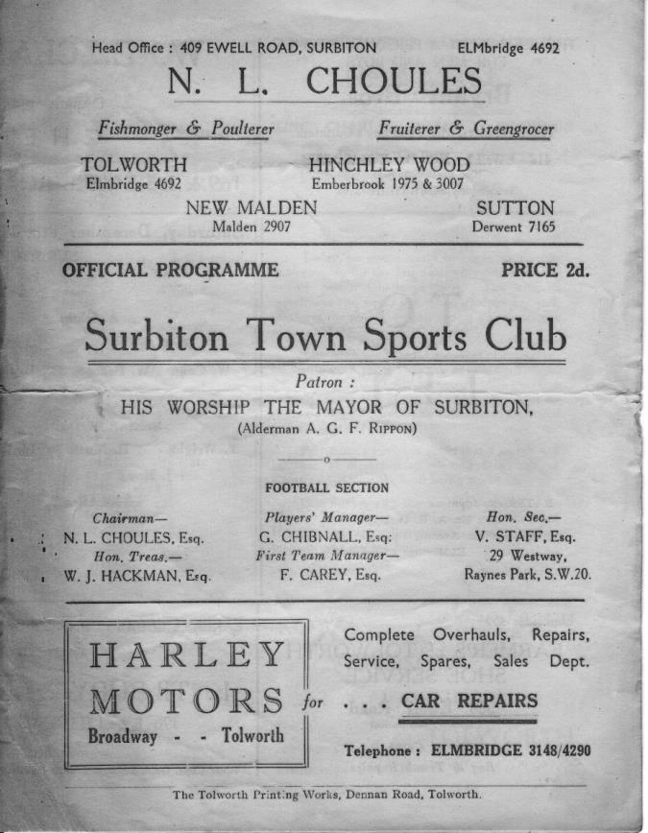
Playing at Riverhill, near to the Worcester Park Road, Surbiton Town entered the Surrey Senior League in the 1949/50 season, remaining there until 1958. They secured a couple of top five finishes in their first two seasons before a seventh place was followed by six lower half finishes and a wooden spoon in 1957.

We first met in the 1950/51 season when we were drawn together in the Amateur Cup and won comfortably by four goals to two on 23rd September 1950. Later that season we met in a friendly match (which back in those days counted as competitive fixtures) to celebrate the Festival of Britain week. Many matches across the country were played in the May of 1951 and we drew 3-3 on the 19th on their first visit to West Street.

We then met twice more the following season, this time in the Surrey Senior Cup. This was a much closer affair and the two teams were level at 3-3 at the conclusion of the ninety minutes with the match being abandoned due to bad light with only five minutes of the extra time period being played. Two weeks later on 8th December1951, the clubs met for a replay at Riverhill which was described by the local papers as our worst display of the season, even though we scraped through 4-3 in the end. (see programme above)

It was an Amateur Cup meeting that brought us together once again in October 1953, but two Bill Wiles goals enabled us to progress easily enough with a 2-0 win. However, our final meeting was even easier, just two years later on 1st October 1955. We were due to meet at Riverhill in an Amateur Cup tie once again but for some reason this match was switched to West Street. We had a number of new signings that season, most notably a young lad who had come from Surbiton by the name of Dave Hermitage and he scored four times against his former club in a 10-0 win.

Although finishing 11th out of 16 in 1957/58 this was to be their final season of senior football and they resigned from the league. It is not clear whether they folded at that point, or indeed whether they have any connection whatsoever with Surbiton Byron, a Surrey Senior League team from the sixties. I know that they were playing in Sunday football in the early nineties as they defeated the Epsom and Ewell Supporters F.C. in a League Cup Final in 1992 at Dorking’s Meadowbank ground and we had also played at Riverhill that season in League contests. However, in recent years we have held friendlies at the club, including one against Hoddesdon Town, although by this time the original pitch was partly covered by a karting track so we were not playing on the site of the old pitch.

Sutton Common Rovers: Played 10 - W8 D1 L1 - F27 A12 - PPG - 2.50 - Fantastic

We now move on to one of our current opponents in Sutton Common Rovers. As with Surbiton Town above, they were another Sunday League football club in the eighties and nineties and the Epsom and Ewell Supporters F.C. played their reserves on a few occasions. In fact on a personal note, my final match of football came against them in a pre-season friendly in August 1998 following which I realised that I was getting too old for this game!

Their Senior side were one of the best in the area and joined the football pyramid a few years later and moving up rapidly, despite the absence of a home ground in the Borough. They spent time at River Lane in Fetcham, now used by the Leatherhead Youth development team before joining the Combined Counties League and sharing at Cobham F.C. with a name change to Mole Valley SCR.

Promotion to Step Five came quickly, mostly on the back of Jay Holden’s phenomenal goal scoring ability and we first met at this level in a League match at Merstham on Saturday 21st August 2010. Despite doing much of the work and then finally going ahead near the end, a late Holden equaliser gave the club a hard earned point. Then in the final match of the season on 28th April 2011 they defeated us 4-1 at Cobham.

Since that time things have improved for us. We defeated them home and away the following season which started badly for them and ended in their relegation. Jay Holden even came over to us briefly, although he didn’t have great success and was also unfortunate to be sent off at Molesey; a suspension that remains to my knowledge the only time in club history we have ever been able to overturn a suspension. However in 2012/13 they bounced straight back and from 2013/14 we have met regularly in league action, although all six matches have gone our way.

Our most recent trip was not to Cobham, but to Sutton United’s Gander Green Lane where the club were able to relocate to as part of a ground share agreement on the astroturf there and have changed their name back to Sutton Common Rovers. We narrowly won 2-1 with Michael Eacott saving a late penalty from Jay Holden of all people and won the home match 3-1 on 19th December 2015 with all the goals coming in the second half.

The future appears bright for Sutton Common Rovers. Now settled back in their home borough, attempts continue to secure a new ground of their own and they have identified a site that may in due course be able to get planning permission. Only when a club gets its own base can they realise their full potential and should this happen then I believe they will remain a solid Step Five club, rather than one that is constantly looking at the lower end of the table, as is the case currently.

Combined Counties League Premier Division Opponents
All-time Records
incl Saturday 15th October | P | W | D | L | F | A | PPG | GD | Best  Win | Worst  Loss
Abbey Rangers | 2 | 2 | 0 | 0 | 8 | 1 | 3.00 | +7 | 7-1 | X
Bedfont & Feltham | 1 | 1 | 0 | 0 | 9 | 2 | 3.00 | +7 | 9-2 | X
Spelthorne Sports* | 5 | 4 | 1 | 0 | 15 | 6 | 2.60 | +9 | 6-2 | X
Sutton Common Rovers | 10 | 8 | 1 | 1 | 27 | 12 | 2.50 | +15 | 4-0 | 1-4
Horley Town | 29 | 20 | 5 | 4 | 65 | 30 | 2.24 | +35 | 6-0 | 1-3
Colliers Wood United | 22 | 14 | 2 | 6 | 45 | 33 | 2.00 | +12 | 4-0 | 0-5
Westfield | 19 | 11 | 3 | 5 | 40 | 31 | 1.89 | +9 | 6-1 | 0-4
Bedfont Sports | 9 | 5 | 2 | 2 | 13 | 10 | 1.89 | +3 | 3-0 | 0-4
Farnham Town | 14 | 8 | 2 | 4 | 25 | 23 | 1.86 | +2 | 3-1 | 1-4
Knaphill | 7 | 4 | 1 | 2 | 15 | 8 | 1.86 | +3 | 4-0 | 1-2
Hanworth Villa | 15 | 8 | 3 | 4 | 38 | 26 | 1.80 | +12 | 5-0 | 1-4
Guildford City | 16 | 9 | 1 | 6 | 32 | 22 | 1.75 | +10 | 5-1 | 1-5
Raynes Park Vale | 26 | 13 | 5 | 8 | 57 | 36 | 1.69 | +21 | 6-1 | 0-2
Badshot Lea | 18 | 8 | 3 | 7 | 35 | 34 | 1.67 | +1 | 4-1 | 0-4
Walton & Hersham | 50 | 24 | 10 | 16 | 101 | 97 | 1.64 | +4 | 6-0 | 0-8
Camberley Town* | 89 | 38 | 22 | 28 | 158 | 123 | 1.52 | +35 | 9-1 | 0-4
Hartley Wintney | 10 | 4 | 3 | 3 | 25 | 17 | 1.50 | +8 | 5-0 | 2-4
Windsor | 48 | 18 | 12 | 18 | 88 | 90 | 1.38 | -2 | 4-0 | 0-6
Chertsey Town | 47 | 17 | 5 | 25 | 70 | 86 | 1.19 | -16 | 3-0 | 0-7
AFC Hayes | 8 | 2 | 2 | 4 | 16 | 15 | 1.00 | +1 | 7-0 | 0-3
North Greenford United | 11 | 3 | 2 | 6 | 15 | 20 | 1.00 | -5 | 3-0 | 1-4
CB Hounslow United | 2 | 0 | 0 | 2 | 2 | 7 | 0.00 | -5 | X | 1-5
* includes one abandoned match v Camberley and one loss on penalties v Spelthorne

EL Records Premier Challenge Cup
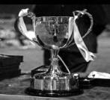
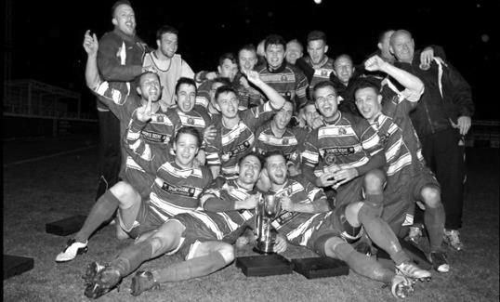
First Round
Redhill | 4-0 | Bedfont & Feltham
Match played at Bedfont & Feltham F.C.
Spelthorne Sports | 1-4 | Sutton Common Rovers
Knaphill | 0-2 | Camberley Town
Worcester Park | 2-1 | Dorking
Epsom & Ewell | 1-0 | Abbey Rangers
Westfield | 3-2 | North Greenford United
Cobham | 3-2+ | Bagshot
CB Hounslow United | 3-4 | Farnham Town
South Park Reserves | 1-4 | Balham
Second Round
Hanworth Villa | 2-4+ | Epsom and Ewell
AFC Hayes | 3-4 | Balham
Epsom Athletic | 1-5 | Windsor
Sutton Common Rovers | 14/11 | Bedfont Sports
Raynes Park Vale | 2-0 | Colliers Wood United
Frimley Green | 1-2 | Banstead Athletic
Westfield | 1/11 | Redhill
Staines Lammas | 0-1 | Farnham Town
Worcester Park | 19/11 | Cove
Badshot Lea | 0-5 | Guildford City
Chertsey Town | 1-2 | Camberley Town
Cobham | 1-3 | Chessington & Hook United
Hartley Wintney | 4-0 | AC London
Horley Town | 2-2+ | Sheerwater
Horley Town won 5-4 on penalties
Walton & Hersham | 1/11 | Eversley & California
Ash United | 2-0 | Farleigh Rovers
Third Round
Banstead Athletic | V | Westfield / Redhill
SCR / Bedfont Sports | V | Walton & H / Eversley & C
Farnham Town | V | Camberley Town
Ash United | V | Windsor
Raynes Park Vale | V | Hartley Wintney
Guildford City | V | Balham
Horley Town | V | Chessington & Hook United
Worcester Park / Cove | V | Epsom & Ewell

Player Sponsorship
Here is the current list for the 2016/17 season showing all of our players and Management that are currently available for sponsorship.

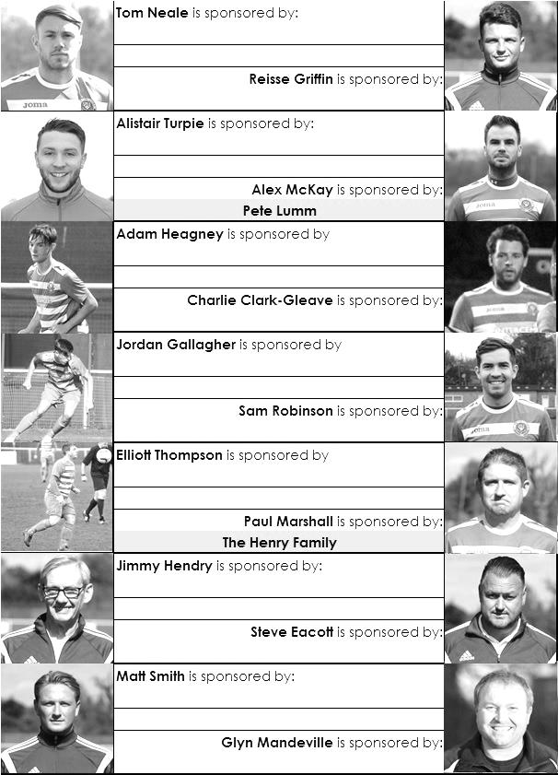

Sponsorship costs just £40 and it is easy to do. Just select a player who has not been previously sponsored and let a Committee Member know that you would like to sponsor them. Beware though. Until we have received the money it is possible for someone to jump in front of you, so don’t delay, sponsor today!
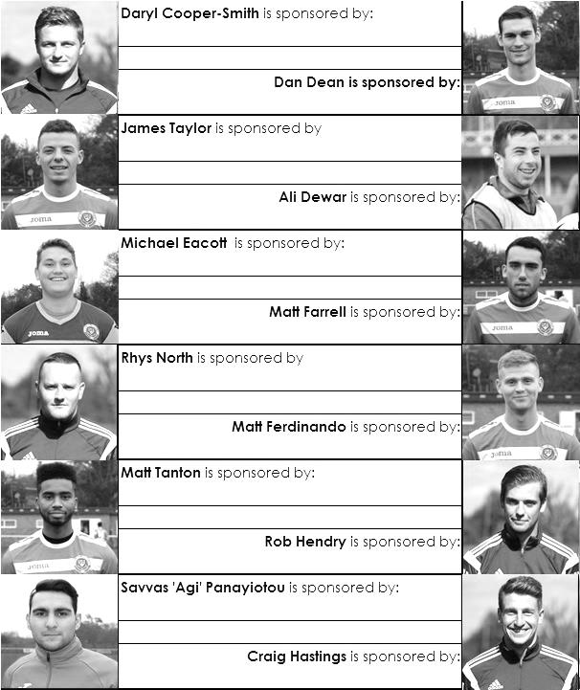

Match and Ball Sponsorships – 2016/17
Opponent | Date | Match Sponsor | Ball Sponsor
Gravesham Borough | 07/08/16 | Club President - Stella Lamont
Gravesham Borough | 07/08/16 | Relocation Committee Member - Mike Lovett
CB Hounslow United | 16/08/16 | EEFC Management Committee
Abbey Rangers | 23/08/16 | Steve & Geoff Dyke
Horley Town (11.30am) | 29/08/16 | In Memory of Chris Henry
Abbey Rangers (LC) | 06/09/16 | Paul Merritt
Camberley Town | 10/09/16 | Building Shop Ltd
Knaphill | 24/09/16 | Pete Lumm
Bridon Ropes (FAV) | 22/10/16 | George and Joseph Saunders
Sutton Common Rovers | 08/11/15
Windsor | 15/11/16
Bedfont Sports | 19/11/16
AFC Hayes | 26/11/16
Chipstead (SSC) | 06/12/16
Hanworth Villa | 13/12/16
Chertsey Town | 17/12/16
Raynes Park Vale (11.30am) | 27/12/16
Spelthorne Sports | 07/01/17
Guildford City | 17/01/17
Bedfont & Feltham | 21/01/17 | Programme Editor - Richard Lambert
Badshot Lea | 04/02/17
Westfield | 18/02/17
Walton & Hersham | 04/03/17
Hartley Wintney | 18/03/17
Farnham Town | 25/03/17
Colliers Wood United (1.00pm) | 14/04/17 | Good Friday match – make a note!
North Greenford United | 22/04/17 | Club President - Stella Lamont
For League, League Cup and Surrey Senior Cup Matches:
Match sponsorship - £40.00 Match ball sponsorship - £25.00. Combined £55.00.
For F.A. Cup and F.A. Vase matches:
Match sponsorship - £50.00 Match ball sponsorship - £30.00. Combined £65.00.

Sponsorship includes: (x2 for match, x3 for match and ball)

Admission, programmes, hospitality and advertising and mascot for the day (if required).
If you are interested, just speak to a Committee Member, or drop me an email at: richard.c.lambert@gmail.com

We also thank our Kit Sponsors INTERCEM

Salts Super Six Predictor
The Salts Super Six Predictor is live again for today’s match and the tickets are on sale at today’s game to the left of the gate.

The competition is easy to play! To win, you simply need to predict the results of six matches correctly from the three options, fill in the form and make sure it is back with our seller before the deadline on the ticket. The latest fixtures are shown lower down.

If you are a club regular, you just need to place your name on the sheet, although if you aren’t, then we’ll need a contact number from you too. We will announce any winners on the website within three working days, so don’t worry, we won’t miss you!

We had a big jackpot winner last year and it is getting quite large again! It is currently £225 and you’ll always know the size of the pot before you enter.

Please note that if there is more than one winner, the prize pot would be shared between the winners. All you need to do now is have a go, as many times as you like!

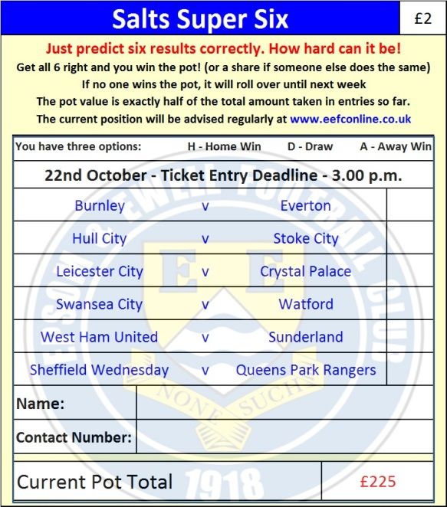

Good luck!

Buildbase F.A. Vase – First Round
Saturday, 22nd October 2016 - Kick-off 3.00 p.m.
Epsom and Ewell  (Royal Blue & White hoops) | V |  | Bridon Ropes  (All Burgundy)
Squad | NUMBERS
Michael Eacott |  |  | Anthony Gaughan
Adam Heagney |  |  | Jack Turner
Matt Tanton |  |  | Matt Dennis
© Dan Dean |  |  | Eamon Gaughan
James Taylor |  |  | Oliver Hickman
Alex McKay |  |  | John Woodcock
Reisse Griffin |  |  | Finlay Chambers
Matt Farrell |  |  | Kemal Chakarto
Daryl Cooper-Smith |  |  | Kieran Fanner
Matt Ferdinando |  |  | Nick Dunsdon
Rob Hendry |  |  | Adam Smith
Savvas ‘Agi’ Panayiotou |  |  | Oliver Soulsby
Craig Hastings |  |  | James Doherty
Jason Nwachukwu |  |  | Jacob De Vries
Tom Neale |  |  | Joe Hall
Charlie Clark-Gleave |  |  | George Maddocks
Alistair Turpie |  |  | Adam Saunders
Jordan Gallagher |  |  | Taylor Bowley
Matt Smith |  |  | Abdul Al-Kamara
Sam Robinson |  |  | Abel Olatungi
Glyn Mandeville | MANAGER |  | Mark Murison
Matt Smith | ASSISTANT |  | Scott Taylor
Steve Eacott / Alex McKay / Jimmy Hendry | COACHES / PHYSIO |  | Lukasz Nowak
REFEREE: J.Bolland (Englefield Green)
ASSISTANTS: J.Oxenham (Egham), B.O’Toole (Isleworth)
Today’s Match and Match Ball are sponsored by George and Joseph Saunders

OUR NEXT VISITORS TO HIGH ROAD
Sutton Common Rovers
Combined Counties League – Premier Division
Tuesday 8th November 2016 – 7.45 p.m.

